
CS 319 - Object-Oriented Software Engineering
Analysis Report
Pong
Section 2-Group 2
Mehmet Çağrı Kaymak
Abdullah Alperen
Mehmet Fatih Çağıl
Doğukan Ömer Gür

Table of Contents
1. Introduction 3
2. Requirement Analysis 3
2.1. Overview 3
2.2. Functional Requirements 7
2.3. Non-Functional Requirements 7
2.4. Constraints 7
2.5. Scenario 7
2.6. Use Case Models 7
2.7. User Interface 7
3. Analysis 7
3.1. Object Model 7
3.1.1. Domain Lexicon 7
3.1.2. Class Diagram 7
3.2. Dynamic Models 8
3.2.1. State Chart 8
3.2.2. Sequence Diagram 8
4. Conclusion 8

Introduction
Pong is one of the first popular games of the video game industry. Basically, it is a two dimensional tennis game. Aim of the game is reaching a certain point before the opponent; points are earned when opponent cannot return the ball. There are two paddles in the opposite ends of the screen that controlled by two different users. Different than the original game, we are planning to add brick as obstacles and some features as power-ups; with the power-ups movement speed or size of the paddle will be changed. (Or different features will be added to paddle). Same power-up functionality will be available for the ball. As a last difference, we are going to add different game fields. Classic pong game has a rectangular game field, we are going to add circular and other different game fields. Our game will be compatible with PCs and will be a game for 2 players.
A very basic pong game can be found at http://www.ponggame.org

Requirement Analysis

Overview
When the game opened, a menu will be seen in the screen. This menu is the main menu. There will be 5 different options as “Play Game with AI”, “Play Game with 2 Players”, “Options”, “Credits” and “Quit”. When “Quit” is selected the game will be closed as the name implies. At the “Credits” menu, information about game will be showed. In the “Options” menu, user can be able to change some features in the game. There will be a sound switch which allows user to enable or disable the gameplay music. User can be change the background image from this menu. Any image can be used as background image. Users can change the control buttons if the sticks in the main menu, buttons can be changed with other keyboard buttons if they are not used. When user selects the “Single Player”, screen will show up. In this screen, user can be able to change the difficulty level of AI, type of game field and user will be select one of the 6 brick presets and the score limit of the game. Then the game will start. “Multiplayer” is almost identical to “Single Player” menu, but there is not difficulty level for AI since AI is not involved to game. Purpose of the game is forcing the opponent to fail the return the ball. 2 different users are going to control different sticks; they will try to hit the ball until one of the fails. When one of them fails, other player will gain score. When one of the players reach the limit, game will be over and that player will be decided as the winner.
During the game there are going to be positive powers and negative powers. When a player sends the ball to a power, that user will gain that power. These powers will change the features of the sticks and the ball. Also there will be brick on the game field that selected by user before starting the game.
When one of the players presses “P” from keyboard, game will be paused. In the pause menu, there are going be 3 different selections; “resume” which continues the game, “restart” which starts over the game and “back to main menu” which goes back to main menu.
Players are going to control the sticks with keyboard, one of the sticks will be controlled with “W” and “S”, other one with “O” and “L”. These buttons can be changed in the options menu. When one of the players gain score, powers will be deleted.
    - Powers
Powers will show up randomly and when the ball collides with a power the last stick that hit the ball is going to has the power.
2.1.1.1 List of Positive Powers
Long Stick: Length of the stick will be increased when this power is gained, so that player will be able to hit the ball more easily. Having another Long Stick power while one is active will increase the duration of the power. If the user has Short Stick power this will neutralize that power.
Fast Stick: Movement speed of the stick will be increased when this power is gained. Having another Fast Stick power while one is active will increase the duration of the power. If the user has Slow Stick power this will neutralize that power.
Slow Ball: This power will decrease the speed of the ball. Default speed of the ball can be only decrease 1 level between 2 scores, this means that having same power will increase the duration of the power.
Big Ball: This power will increase the size of the ball. Having more than 1 power will increase the duration of the power.
2.1.1.2 List of Negative Powers
Short Stick: Length of the stick will be decreased when this power is gained. Having another Short Stick power while one is active will increase the duration of the power. If the user has Long Stick power this will neutralize that power.
Slow Stick: Movement speed of the stick will be decreased when this power is gained. Having another Slow Stick power while one is active will increase the duration of the power. If the user has Fast Stick power this will neutralize that power.
Fast Ball: This power will increase the speed of the ball. Default speed of the ball can be increased 3 levels. Having more than 3 powers between 2 scores will increase the duration of the power.
Small Ball: This power will decrease the size of the ball. Having more than 1 power will increase the duration of the power.
2.1.2 Bricks
Regular Brick: This type of brick will act like an ordinary obstacle, when the ball hits a regular brick it will bounce as normal. This type of brick will be broken after one hit.
Figure 1: Regular Brıck
Fast Brick: When the ball hits a fast brick, speed of the ball will be increase for a small amount of time. This type of brick will be broken after one hit.
Figure 2: Fast Brick
Strong Brick: This type of brick is same as Regular Brick but will be broken after 3 hits instead of 1 hit.
Figure 3: Strong Brick
Negative Brick: When the ball hits a negative brick, it will bounce to where it came. This brick will be broken after one hit.
Figure 4: Negative Brick

2.1.3 Game Field
Game Field is the field that action is happening. When the ball hits the left or right sides of the rectangular game play, the player on the opposite side will gain a score. If the game field is circular, player that hit the ball out of the game field will gain a score.
2.1.4 Ball
Ball is the one of the two main components of the game. Aim of the game depends on the ball, players cannot control the ball directly, they have to use sticks to control the ball. If the ball goes to back of the game field, there is a score in the game.
 Figure 5: Ball

2.1.5 Stick
Sticks are the only components that players can control. Sticks can be moved vertically (with respect to game field) with keyboard buttons. By having powers features of sticks will be change.
Figure 6: Stick

Functional Requirements
User(s) is going to control the stick with keyboard buttons, which can be changeable at the options menu.
In the options menu user can enable or disable the game music, change the background image and change the keyboard input buttons if desired.
Game can be paused during gameplay with button “P” and user(s) can continue to game or go back to main menu. When user select to go back to main menu when game is paused, all the progress will be lost.
Powers will change the specific features of the game and powers are going to be reset when there is a score.
Right before starting to game, user can choose game field type, brick set, AI difficulty and score limit. When the score limit is reached game will be over.

Non-Functional Requirements
User can be able to start the game with 2 mouse clicks.
System requirements are going to be kept as low as possible because we do not want it cost too much in terms of performance, so that user can have a smooth game experience.
User interface of the game will be plain and simple for ease of use.
The game will be written carefully in terms of reusability and extendibility so that it can be modified easily on future.
The project should be licensed under Apache 2.0 open-source license, which is one of the most widely used licenses by open-source projects.
Any system that has Java libraries installed will be able to run the game.

Constraints
The game is going to be written in Java.
The game will support English since English is widely known around the world.

Scenario
Scenario Name | HitBallByUser
Participating Actor Instances | Fatih: User
Flow of Events | Fatih wants to hit the ball and bounce it back to protect his goal.
Flow of Events | Fatih presses the movement key that moves the user’s bar to the right
Flow of Events | System responds to the input and moves the bar to the right, as long as Fatih presses on the key.
Flow of Events | After Fatih presses the right key and moves the bar, the ball and the bar collide.
Flow of Events | System detects the collision and changes the ball’s direction accordingly.
Flow of Events | Ball bounces back within the rules of the physical collision and drifts away from Fatih’s goal, system draws the final states of the objects after collision.

Scenario Name | ChangePreferences
Participating Actor Instances | Fatih: User
Flow of Events | Fatih wants to change the settings of his profile from main menu. He goes to options menu to make the necessary changes
Flow of Events | Fatih mutes the sound to eliminate any in-game sound.
Flow of Events | He also changes the background and chooses one of the options provided on the screen
Flow of Events | To change the move up control of first player, he click and change the current control key.
Flow of Events | Fatih saves the changes before leaving the Options Screen to apply the changes he made on preferences.
Flow of Events | System updates the preferences associated with Fatih’s profile and it makes them available in the next game Fatih plays.

Scenario Name | BreakBrick
Participating Actor Instances | Fatih: User
Flow of Events | Fatih catches the ball with his stick by moving it.
Flow of Events | When he hits the ball, it drifts towards the brick with each periodical update of the system and reaches the brick within a certain number of update loop.
Flow of Events | System detects that collision occurs between the puck and the respective breakable brick.
Flow of Events | After collision ball breaks the brick that it get into contact with.
Flow of Events | System handles the collision according to elastic collision principles and ball attains its new vector keeps on moving.

Use Case Models
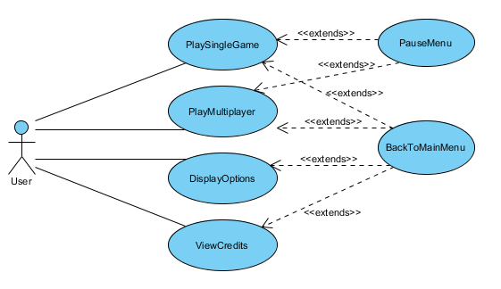
Figure 7: Use Case Model
Scenario Name | PlaySingleGame
Participating Actor Instances | Initiated by User
Flow of Events | 1. System shows User the Main Menu
Flow of Events | 2. User clicks on Single Player option
Flow of Events | 3. System shows the available maps, choose friction rate and difficulty of artificial intelligence, select the brick type by clicking on them with the mouse.
Flow of Events | 4. User clicks on play button.
Flow of Events | 5. System starts the game. The game is launched with map specifications. The bricks on the map are determined by the preferences. Game starts with 0 to 0 score.
Flow of Events | 6. System launches the ball from its starting point with a fixed starting velocity and accelerates using its algorithms.
Flow of Events | 7. User presses up and/or down arrow keys to play the game. If the user has assigned another keys (from the Options Menu), these keys are used to play the game.
Flow of Events | 8. System responds to the respective arrow key by moving the user stick up or down. When the ball and a stick collides system uses its algorithms to bounce the ball. The stick movement at the instance of collision affects the ball’s movement by either increasing or decreasing its movement on the x-axis and y-axis by determining the total speed depending on friction rate.
Flow of Events | 11. If the User couldn’t block the bar with their bar, it means that the AI scores a goal. Likewise, User scores a goal when the AI can’t block the ball with its stick.
Flow of Events | 12. System increases user’s or AI’s score by one and initiates the game from (5). If score of one of them reaches 5, the game terminates and shows the user game score.
Entry Condition | User launches the game.
Exit Condition | User clicks return to main menu button
Quality Requirements | System should response in 1/10 seconds

Scenario Name | PlayMultiplayer
Participating Actor Instances | Initiated by User
Flow of Events | 1. System shows User the Main Menu
Flow of Events | 2. User clicks on Multiplayer option
Flow of Events | 3. System shows the available maps, choose friction rate and select the brick type by clicking on them with the mouse.
Flow of Events | 4. User clicks on play button.
Flow of Events | 5. System starts the game. The game is launched with map specifications. The bricks on the map are determined by the preferences. Game starts with 0 to 0 score.
Flow of Events | 6. System launches the ball from its starting point with a fixed starting velocity and accelerates using its algorithms.
Flow of Events | 7. Player2 presses “w” and “s” while Player1 presses up and/or down arrow keys in order to move their sticks. If any user has assigned another keys (from the Options Menu), these keys are used to play the game.
Flow of Events | 8. System responds to the respective arrow key by moving the user stick up or down. When the ball and a stick collides system uses its algorithms to bounce the ball. The stick movement at the instance of collision affects the ball’s movement by either increasing or decreasing its movement on the x-axis and y-axis by determining the total speed depending on friction rate.
Flow of Events | 11. If a player couldn’t block the bar with their stick, it means that other player scores a goal.
Flow of Events | 12. System increases that user’s score by one and initiates the game from (5). If score of one of them reaches 5, the game terminates and shows the user game score.
Entry Condition | User launches the game.
Exit Condition | User clicks return to main menu button
Quality Requirements | System should response in 1/10 seconds

Scenario Name | DisplayOptions
Participating Actor Instances | Initiated by User
Flow of Events | 1. System brings Main Menu screen when user runs the game.
Flow of Events | 2. User clicks on Options from the Main Menu.
Flow of Events | 3. System shows Options screen.
Flow of Events | 4. User selects the background image.
Flow of Events | 5. User will be able to change background image by selecting a picture from the computer and uploading it to the system.
Flow of Events | 6. User enable or disable the game sound.
Flow of Events | 7. When the sound is enabled, the system plays 8-bit default music of the game in background.
Flow of Events | 8. User clicks Apply button and system updates the display options according to the preferences.
Flow of Events | 9. User clicks Back button
Flow of Events | 10. System opens the Main Menu screen.
Entry Condition | User launches the game.
Exit Condition | User clicks return to main menu button
Quality Requirements | System should response in 1/10 seconds

Scenario Name | PauseorExitGame
Participating Actor Instances | Initiated by User
Flow of Events | 1. System brings Main Menu screen when user runs the game.
Flow of Events | 2. User clicks Single Player or Multiplayer and initiates the preferences of the game.
Flow of Events | 3. User starts to play game.
Flow of Events | 4. User selects the “p” key on keyboard in the game screen.
Flow of Events | 5. System pauses the game. Two options appear on the screen: Resume and Main Menu buttons.
Flow of Events | 6. a. User clicks on Resume
Flow of Events | 7. System returns back to game screen and stars the game with current situation.
Flow of Events | 6. b. User clicks on Main Menu
Flow of Events | 7. System loses the game data and returns to Main Menu screen.
Flow of Events | 8. User clicks on Exit button and closes the game.
Entry Condition | This use case extends the PlayGame (SinglePlayerGame or MultiplayerGame) use case. It is initiated whenever the game is stopped due to a user’s interference.
Exit Condition | User clicks return to main menu button
Quality Requirements | System should response in 1/10 seconds

User Interface
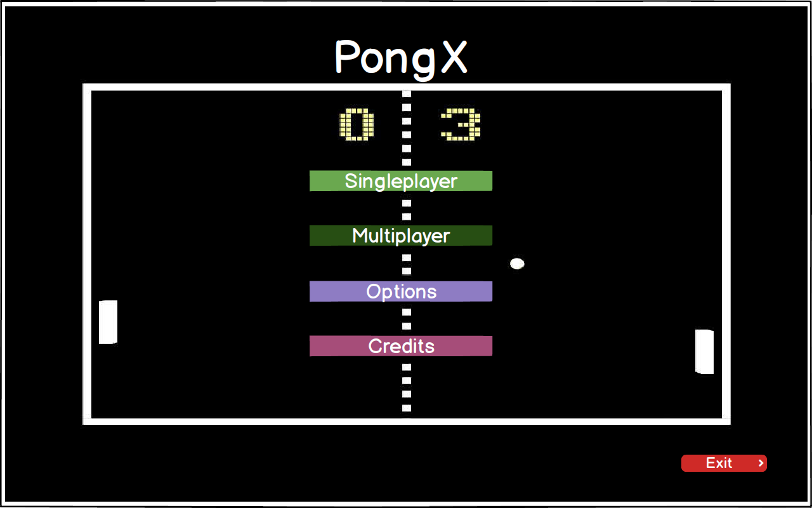
Figure 8: Main Menu
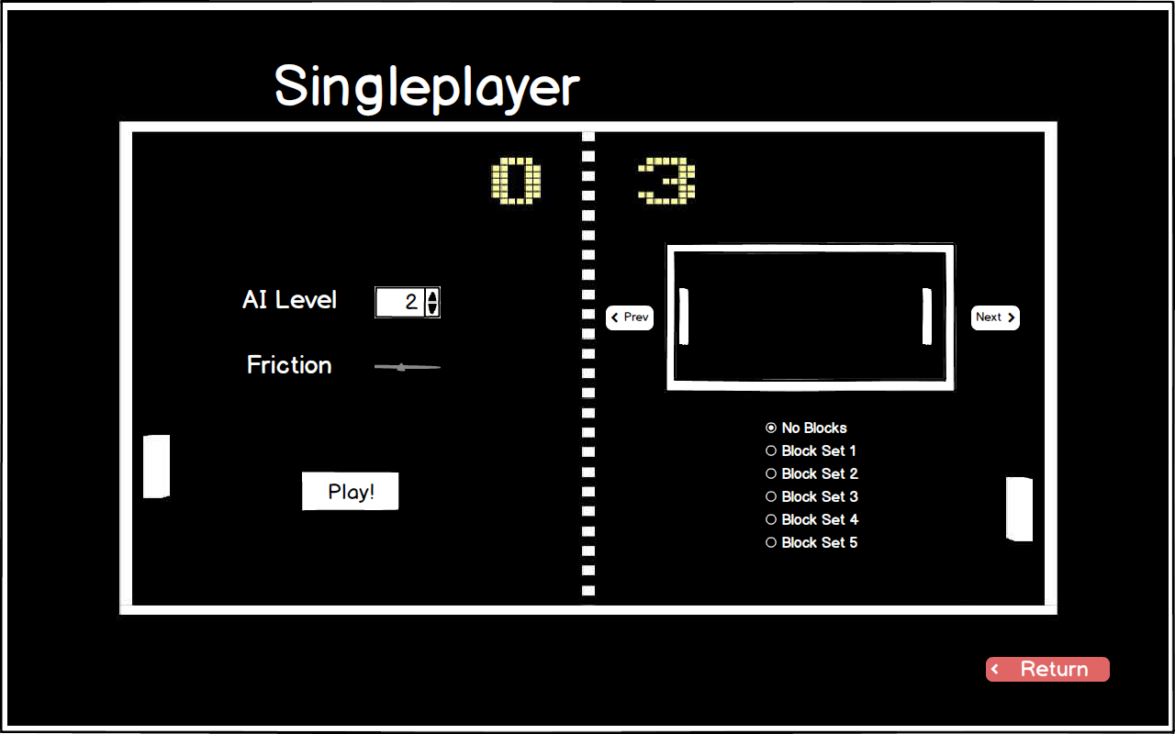
Figure 9: Singleplayer Map Selection Screen

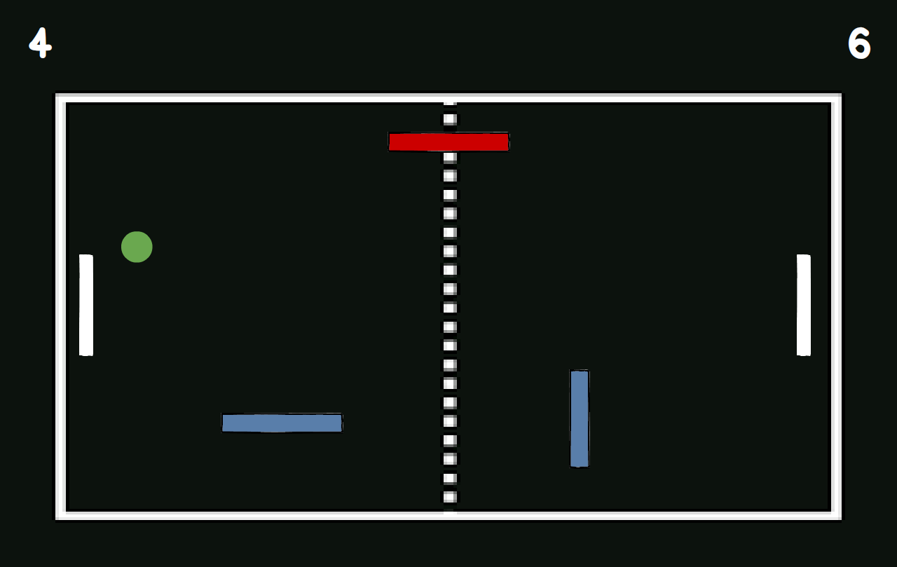
Figure 10: In Game Screen

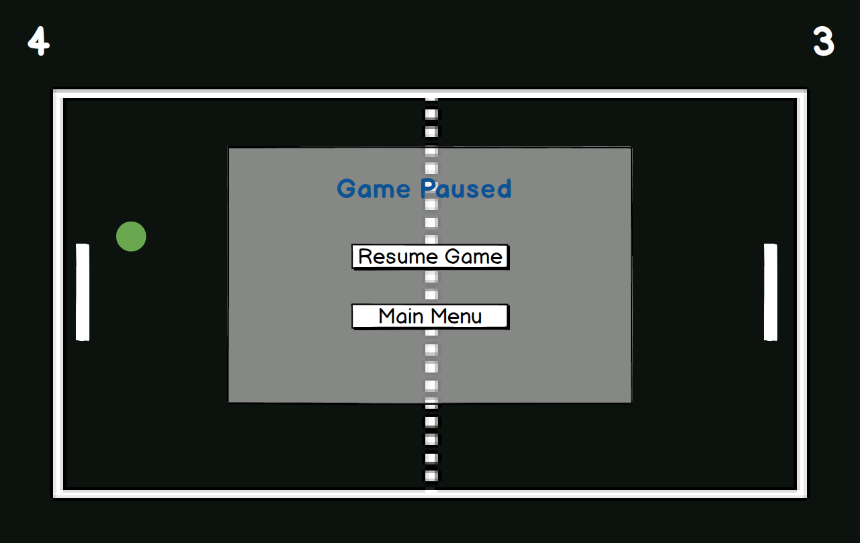
Figure 11: Pause Screen

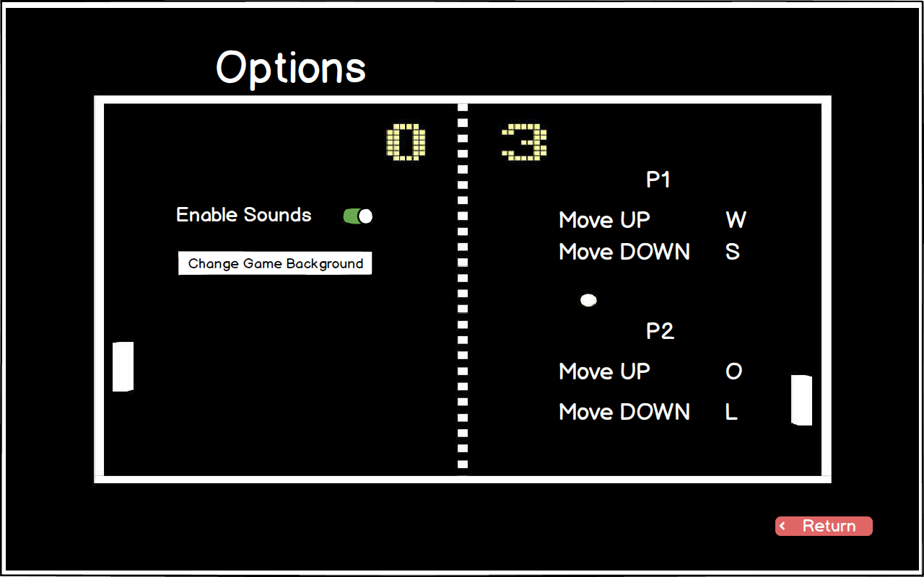
Figure 12: Options Screen

Analysis

Object Model

Domain Lexicon
In this section we will provide some domain information about important terms for designing the project.
Game Field: This entity is a reflection of a field that game is happening. It keeps the sticks, ball, bricks and powers wrapped up. There are different game fields, their only difference are shapes. We have a rectangular game field, circular game field and rounded rectangular game field. This is an environment for other entities to occur.
Powers: There are different types of powers which can affect the process of the game by changing features of the sticks and ball. This is the main difference between our game and classical Pong game.
Stick: This entity is the only object that user can control. User will move it vertically with respect to game field to hit the ball.
Ball: Ball is the other entity object that can be move but not controlled by user. It is going to move according to Newtonian physic laws.
Brick: This is another entity object that exists in the game field. Bricks are not movable objects but can be breakable with ball hits.

Class Diagram
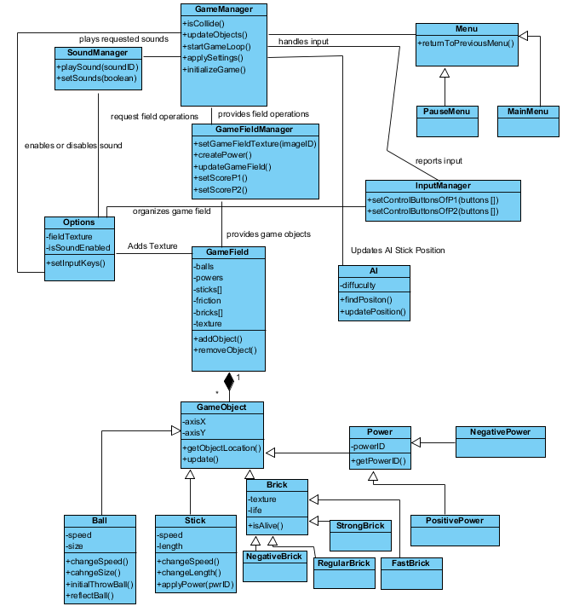
Figure 12: Class Diagram

Dynamic Models

State Chart
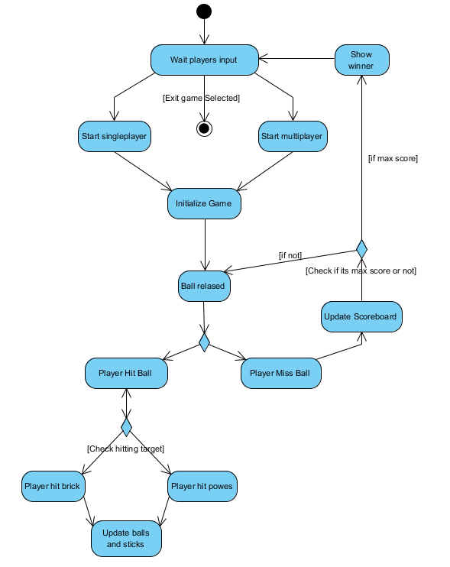
Figure 13: Activity Diagram

Sequence Diagrams
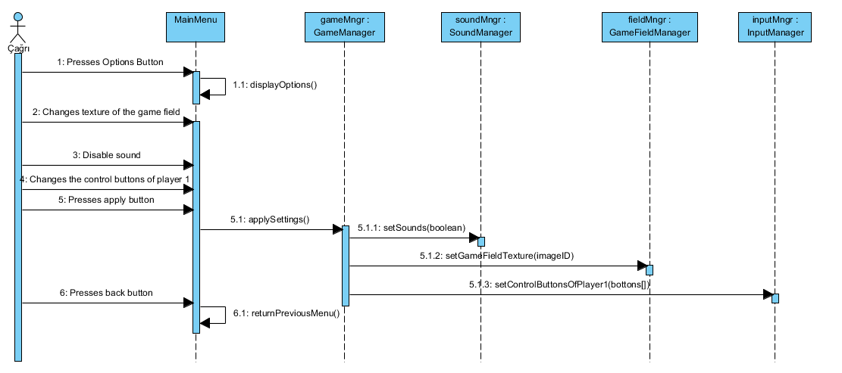
Figure 13: Change settings (Sequence Diagram)
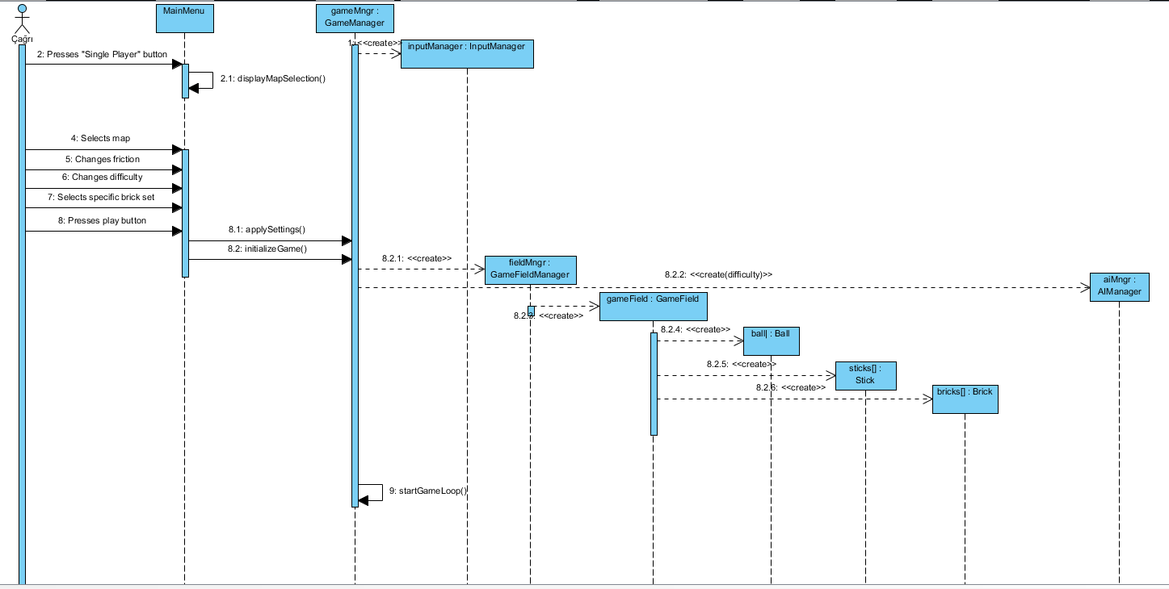
Figure 14: Start Singleplayer game (Sequence Diagram)
This sequence diagram shows that user enters options menu and make some desired changes then click apply button.

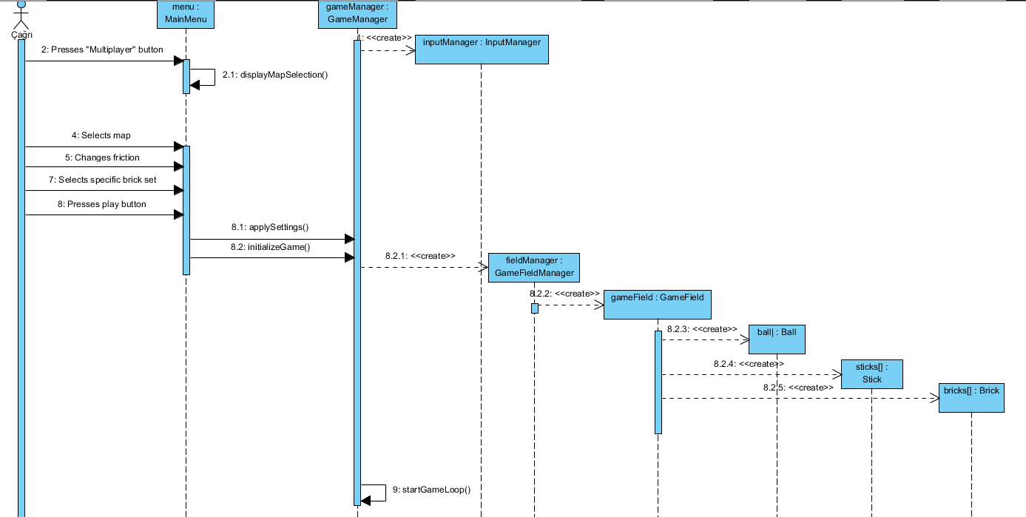
Figure 15: Start Multiplayer game (Sequence Diagram)
Figure 14 and 15 shows that how to start multiplayer and singleplayer game properly.

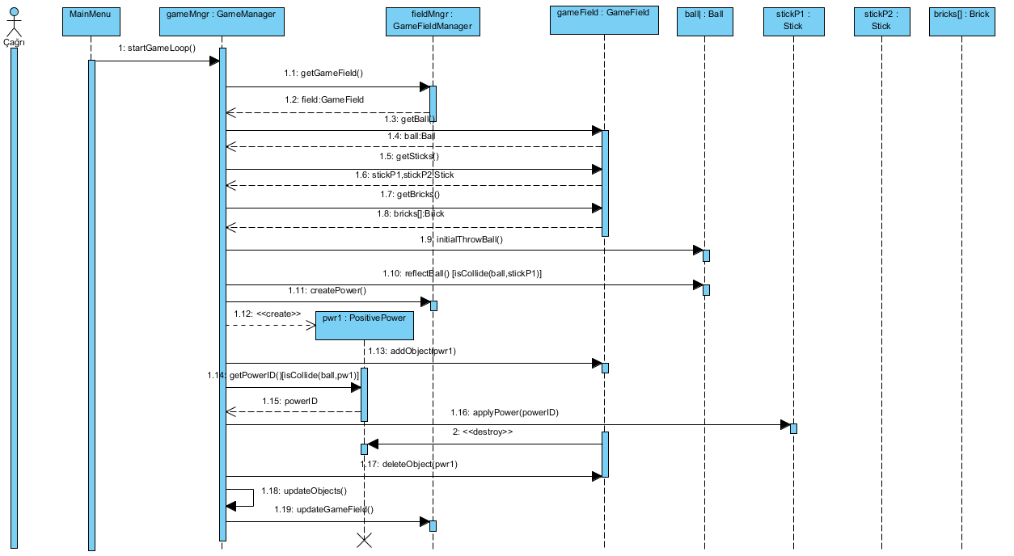
Figure 16: Get Positive Power (Sequence Diagram)
This diagram shows that Player 1 hits the ball and then the ball hits a positive power and player 1 gets this power. Then power is deleted.
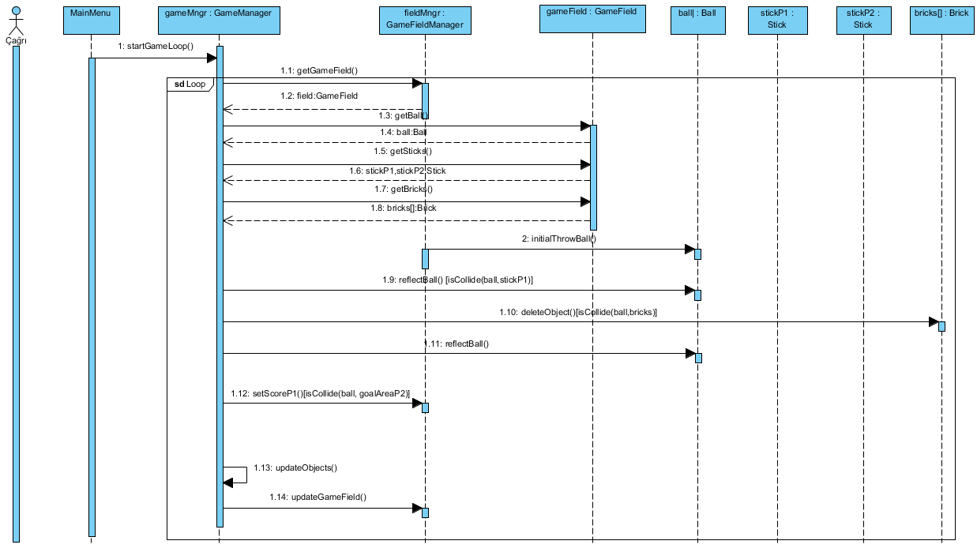
Figure 17: Hitting brick and scoring (Sequence Diagram)
This diagram shows that Player 1 hits the ball and then the ball hits a regular brick and destroy it. That brick is deleted from the array of bricks. After Player 2 miss the ball and Player 1 gains score.

Conclusion
This analysis report helps us to understand design step of our project and give opportunity to study needed concepts to write xPong game. Our report basically focusses on two main topics; firstly, the concepts and features of the projects, secondly the design parts and system diagrams.
In the first part, we ponder on the concepts and the features of the game and we tried to understand what a player can want from a pong game and how can we provide these requirements. Our main concern for this part of the report is to determine the both functional and non-functional features. Because this part will be the foundation of our game we tried to find all requirements which a user want. And we want to ensure game can encounter all the scenarios. We also did a detailed analysis of the similar games to find new ideas and decide which feature is good or bad for our game.
In the second part, we work on our system model. We did thinking on how can we implement the features we decided. In order to understand these designs, we make some diagrams. For use case model we think about what could be the uses of our program and we tried to find out what requirement can real use cases. We also make a sequence diagram to understand how behave our program behave to given instruction by users and how can handle them, we have an activity diagram to show a basic game play progress and what game basically do. Also we make a class diagram to show classes and relations between them. In this diagram we try to show basic attributions and operations of the classes this help when we code the game. Finally, we show some user interface and mock-ups to show what xPong will look like.
As a result we work hard on this analysis report because we are aware of that it will help us in all steps of the development and it helps us the find and encounter problems efficiently in the future.

